Sample Assessment 03

Introduction.

Data presented in this experimental study are both quantitative and qualitative. The weights measured are qualitative, continuous and gender are qualitative. Weights measured in each month is dependent. The sample size of the male category is 9 and the sample size of the female category is 7.

In section 02….

Boxplot.

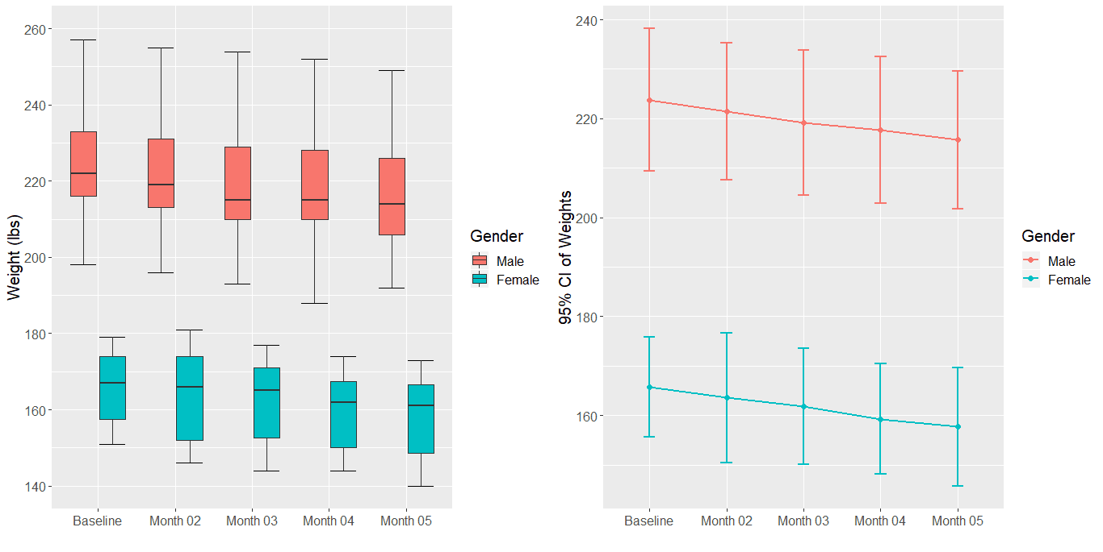

There’s a significant different between the male and female groups where male weights as the male weight ranges are always above the female weight range.

There’s a clear drop in weights regardless of the gender during the time period of the experiment.

**Assumptions**

|  |  |  |  |  |  |  |  |  |  |  |
| --- | --- | --- | --- | --- | --- | --- | --- | --- | --- | --- |
| Statistics | Gender | | | | | | | | | |
| Male | | | | | Female | | | | |
| Mont | | | | | Month | | | | |
| Baseline | 01 | 02 | 03 | 04 | Baseline | 01 | 02 | 03 | 04 |
| Sample Size | 9 | 9 | 9 | 9 | 9 | 7 | 7 | 7 | 7 | 7 |
| Mean | 223.8 | 221.4 | 219.2 | 217.7 | 215.7 | 165.7 | 163.6 | 161.9 | 159.3 | 157.7 |
| Median | 222 | 219 | 215 | 215 | 214 | 167 | 166 | 165 | 162 | 161 |
| Skewness | 0.128 | 0.256 | 0.233 | 0.114 | 0.265 | 0.046 | 0.103 | -0.090 | -0.062 | -0.148 |
| Normally Distributed | Yes | Yes | Yes | Yes | Yes | Yes | Yes | Yes | Yes | Yes |
| p-value | 0.7121 | 0.823 | 0.7245 | 0.8283 | 0.6123 | 0.4555 | 0.3183 | 0.5881 | 0.3701 | 0.4483 |
| Equal variances  assumed | Yes (P-Value - 0.1462 > 0.05) | | | | | | | | | |
| Sphericity  assumed | Yes( P-Value 0.2518) | | | | | | | | | |

Null Hypothesis when testing the assumption of normality.

H0 : No difference exists between the sample and hypothetical distribution;

Null Hypothesis when testing the equal variances.

H0: There’s no difference in variances.

Null Hypothesis when testing the Sphericity.

H0: No difference in the variances of the differences.

**Descriptive Statistics**

|  |  |  |  |  |  |  |  |  |  |  |
| --- | --- | --- | --- | --- | --- | --- | --- | --- | --- | --- |
| Statistics | Gender | | | | | | | | | |
| Male | | | | | Female | | | | |
| Mont | | | | | Month | | | | |
| Baseline | 01 | 02 | 03 | 04 | Baseline | 01 | 02 | 03 | 04 |
| Sample Size | 9 | 9 | 9 | 9 | 9 | 7 | 7 | 7 | 7 | 7 |
| Mean | 223.8 | 221.4 | 219.2 | 217.7 | 215.7 | 165.7 | 163.6 | 161.9 | 159.3 | 157.7 |
| 95% CI (lower) | 209.36 | 207.55 | 204.56 | 202.89 | 201.77 | 155.60 | 150.47 | 150.14 | 148.11 | 145.75 |
| 95% CI (upper) | 238.19 | 235.33 | 233.89 | 232.45 | 229.56 | 175.83 | 176.67 | 173.57 | 170.46 | 169.67 |
| Standard deviation | 18.75 | 18.07 | 19.08 | 19.23 | 18.08 | 10.93 | 14.16 | 12.67 | 12.08 | 12.93 |
| Min | 198 | 196 | 193 | 188 | 192 | 151 | 146 | 144 | 144 | 140 |
| Max | 257 | 255 | 254 | 252 | 249 | 179 | 181 | 177 | 174 | 173 |

**Statistical inference**

|  |  |  |  |  |  |  |
| --- | --- | --- | --- | --- | --- | --- |
| |  |  | | --- | --- | | Effects |  | | Measurements | p-value | |  | | --- | | Effect size | |
| Main effects | Gender | <.001 | 0.780 |
| Time | <.001 | 0.0336 |
| Simple main effects | Gender * Time | 0 .904 | 0.0001 |

**Pairwise comparisons**

**Main Effects**

**Time**

|  |  |  |
| --- | --- | --- |
| Months | Difference (lbs) | P value |
| Baseline - Month.01 | 2.24 | 0.0035 |
| Baseline - Month.02 | 4.21 | <.0001 |
| Baseline - Month.03 | 6.27 | <.0001 |
| Baseline - Month.04 | 8.06 | <.0001 |
| Month.01 - Month.02 | 1.97 | 0.0135 |
| Month.01 - Month.03 | 4.03 | <.0001 |
| Month.01 - Month.04 | 5.82 | <.0001 |
| Month.02 - Month.03 | 2.06 | 0.0085 |
| Month.02 - Month.04 | 3.85 | <.0001 |
| Month.03 - Month.04 | 1.79 | 0.0311 |

**Gender**

|  |  |  |
| --- | --- | --- |
| Months | Difference (lbs) | P value |
| Female - Male | -57.9 | <.0001 |

**Simple main effects (interaction effects)**

|  |  |  |  |  |
| --- | --- | --- | --- | --- |
| Months | Male | | Female | |
| Difference(lbs) | P Value | Difference(lbs) | P Value |
| Baseline - Month.01 | 2.33 | 0.0343 | 2.14 | 0.1293 |
| Baseline - Month.02 | 4.56 | <.0001 | 3.86 | 0.0006 |
| Baseline - Month.03 | 6.11 | <.0001 | 6.43 | <.0001 |
| Baseline - Month.04 | 8.11 | <.0001 | 8 | <.0001 |
| Month.01 - Month.02 | 2.22 | 0.049 | 1.71 | 0.3173 |
| Month.01 - Month.03 | 3.78 | 0.0001 | 4.29 | 0.0001 |
| Month.01 - Month.04 | 5.78 | <.0001 | 5.86 | <.0001 |
| Month.02 - Month.03 | 1.56 | 0.2895 | 2.57 | 0.0424 |
| Month.02 - Month.04 | 3.56 | 0.0003 | 4.14 | 0.0002 |
| Month.03 - Month.04 | 2 | 0.0953 | 1.57 | 0.405 |

|  |  |  |
| --- | --- | --- |
| **Month** | **Male-Female** | **p-value** |
| **Baseline** | -58.1 | <.0001 |
| Month.01 | -57.9 | <.0001 |
| Month.02 | -57.4 | <.0001 |
| Month.03 | -58.4 | <.0001 |
| Month.04 | -58.0 | <.0001 |